

Interclub Snooker Player Guide
How to sign in, manage match night tasks, and follow your season
This guide explains the core tasks that players and managers need for the Interclub Snooker platform. It covers signing in, choosing a team lineup, entering scores and breaks on match night, and the season information players can use through the year.
Most members will simply sign in, check fixtures, view league tables, follow results, see their own stats, and use club tools. Managers have extra match-night actions for team selection and scoring.

Quick role summary
Step | Action | What to check
1 | Player | See your team home page, fixtures, live scores, league tables, personal games, personal stats, and club tools.
2 | Manager | Do everything a player can do, plus pick lineups, publish the team, enter scores, record breaks, and complete the match.
3 | Club member | Use club areas such as table bookings and club competitions, and view league tables where enabled.

Sign in and activate your account
Nobody can self-register. Your account must be created by an administrator. If you receive an activation email, use the button in that email. If your account is already active, sign in with your email and password or Google if that method has been connected to your account.
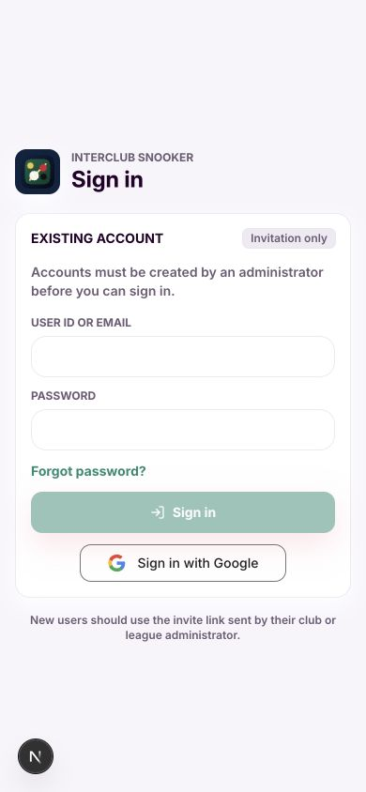 | 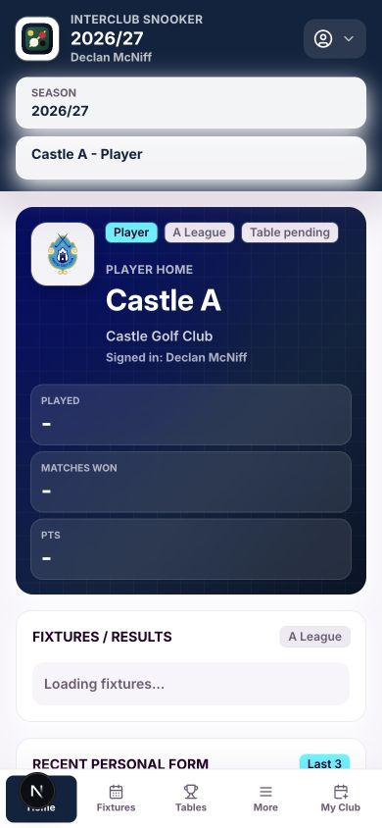
Sign in page for existing users | Player home after signing in

- Open interclubsnooker.com on your phone.
- Enter your user ID or email address and password, or choose Sign in with Google if your account has been connected that way.
- If you have more than one role, choose the correct role from the role selector. If you only have one role, the app keeps the screen simpler and does not show a role switcher.
- Use the bottom navigation to move between Home, Fixtures, Tables, More, and My Club where available.

Picking a team as manager
Managers pick their team from the relevant fixture. Your team match appears in the fixtures area. Open the match, choose each player slot, save a draft if you are still deciding, and publish only when you are ready. Once published, the lineup is locked.
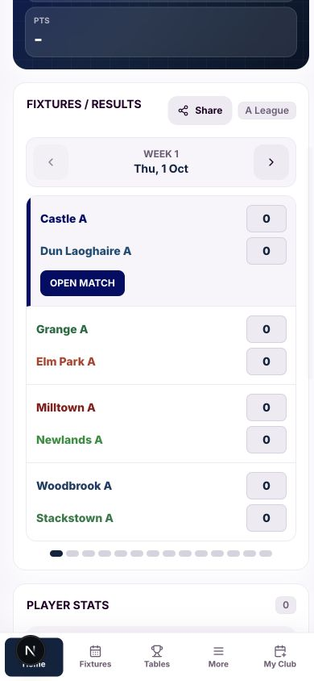 | 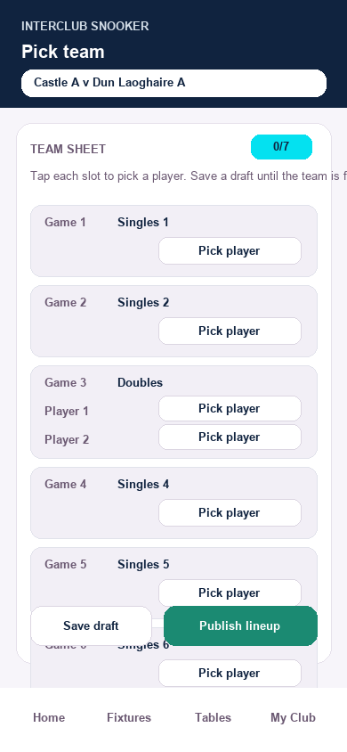
Manager home showing the fixtures and match card | Open match showing the team sheet slots

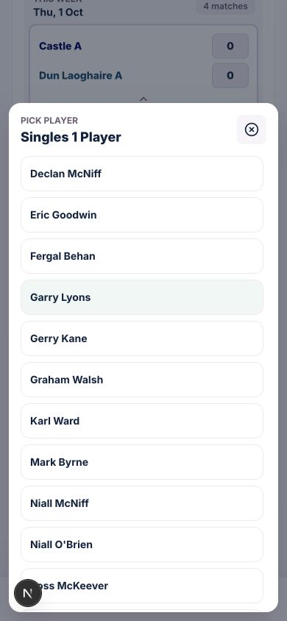 | 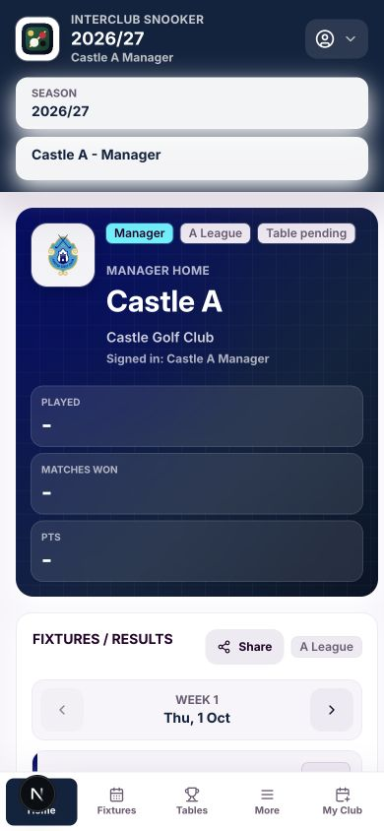
Player picker for a lineup slot | Manager context and season selector

- Go to your fixture from Home or Fixtures.
- Tap your team match to open it.
- Tap Pick player for each singles or doubles slot.
- Use Save draft if the lineup is not final.
- Publish only when the lineup is final. The opposing manager sees the published status.

Entering scores and breaks on match night
When both teams have published their lineups, the match becomes the focus. Managers can enter each game result. Singles are worth one point. A League and B League doubles are worth two points. C League uses singles in games 1, 3 and 5 and doubles in games 2 and 4.
Breaks are optional. Only record a break when it is worth tracking. A recorded break is linked to the player, the game, the match and the season, so it can appear in the player record for that season.
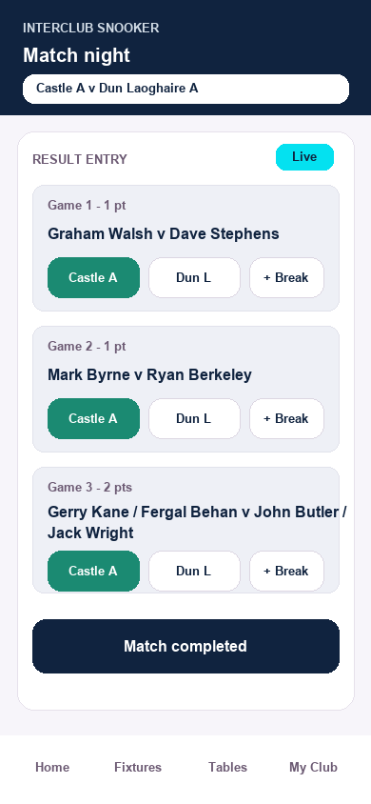 | 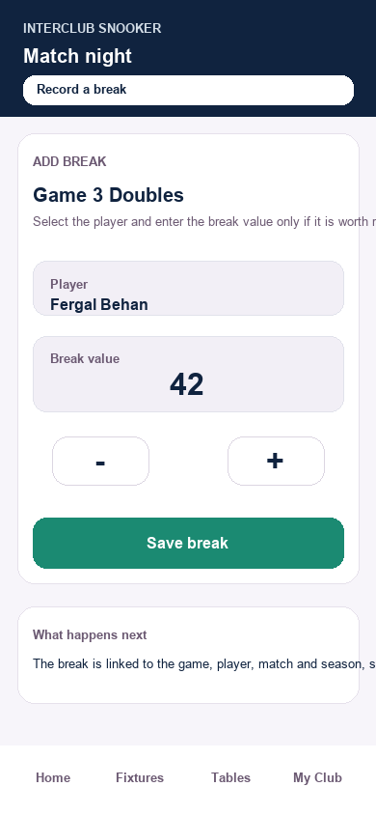
Example score entry area for match night | Example break entry panel

- Open the match once it is active.
- For each game, tap the winning team or player side.
- Use the break action only when a player has made a break that should be recorded.
- Check the running score after each game.
- When all games are entered and checked, a manager presses Match completed. After that the match is locked.

Information available throughout the season
The app is designed so that the information you need most often is no more than a tap or two away. Players see their team position, fixtures, results, personal form and personal stats. Managers also see wider player performance information for the squad.
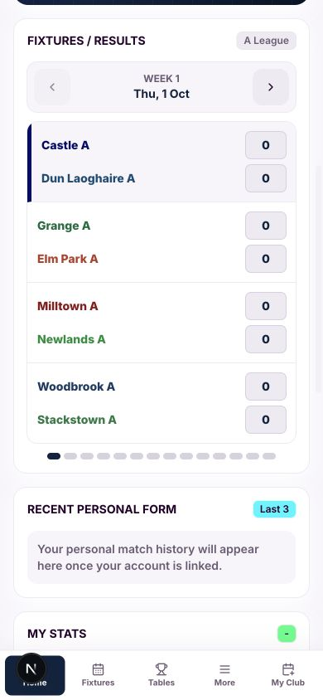 | 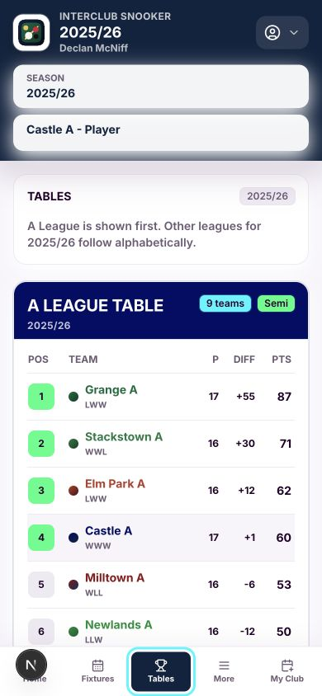
Fixtures and results for the selected week | League tables screen with your league shown first

What players can follow
- Upcoming fixtures and past results for your league.
- Live or in-progress match scores when matches are active.
- League tables for A, B and C leagues, with your own league first for players and managers.
- Your own individual game results, including doubles details where available.
- Your personal win rate, games played, games won and highest break for the selected season.
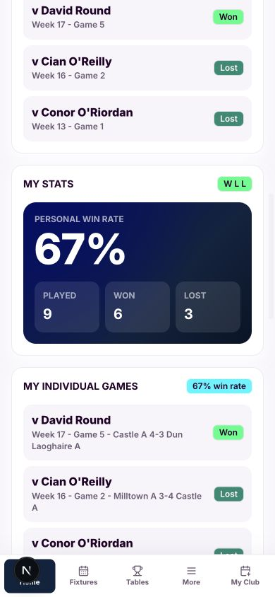 | 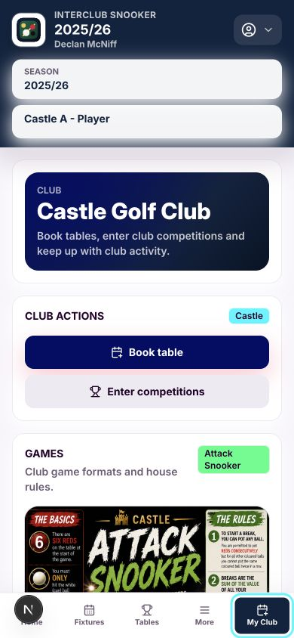
Player stats and individual records | My Club area for club tools

Useful habits during the season
Step | Action | What to check
1 | Before match night | Check the Fixtures panel for the correct week, opponent, venue and match status.
2 | During match night | Players can follow scores. Managers enter scores and breaks when the match is active.
3 | After match night | Review the result, table movement, recent form and personal stats.
4 | Any time | Use My Club for club-specific tools such as competitions, games and table-related areas where enabled.

Notes for managers
- Only managers of the teams involved should be able to pick lineups and enter scores for that match.
- Other players and managers can view live scores when the match is active but cannot edit another team’s match.
- Once a match is marked completed, it should no longer be editable.
- Breaks should be recorded sparingly and accurately because they feed player seasonal records.
This guide is based on the current Interclub Snooker mobile experience and should be updated as the login, lineup and scoring screens evolve.

